|  |  |
| --- | --- |
| **DOCUMENT** | **USE CASE DIAGRAM** |
| **AUTHOR** | **AKANKSHA SRIVASTAVA** |
| **VERSION** | **1** |
| **DATE** | **18-JULY-2020** |

Table of Contents

USE CASES OF MEMBER 2

LIBRARIAN 3

LIBRARY SYSTEM OF RECORDS 4

# USE CASES OF MEMBER

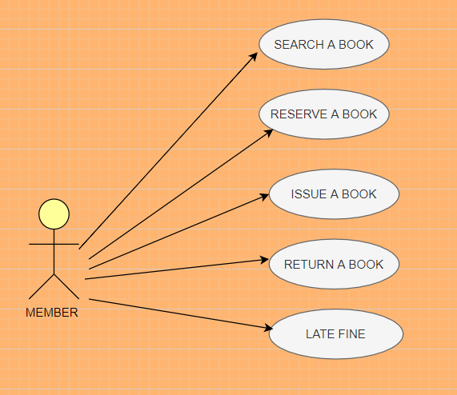

# LIBRARIAN

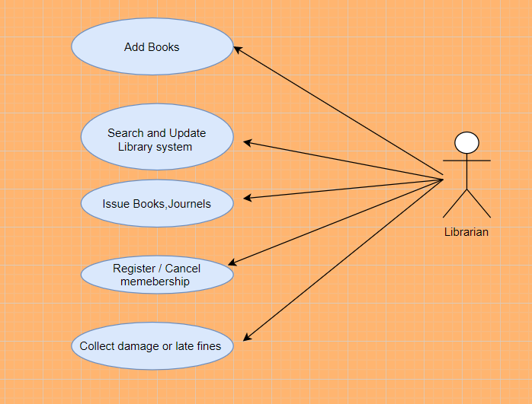

# LIBRARY SYSTEM OF RECORDS

